CP Dynamo Girls Program

The Dynamo program would like to invite all female youth players to be a part of the only Girls Tier I program in the Capital Region.
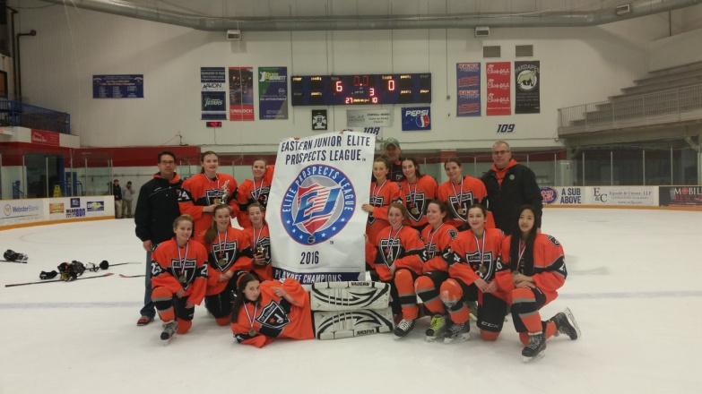
Dynamo Mission:
- establish a strong foundation of hockey skills and concepts through the multi-practice and skills (on and off ice) sessions, in addition to the highly competitive game and tournament schedule.
The 2016-2017 teams include:
- Tier I Girls U12 – Amanda Castignetti (former Div 1 player, RPI)
- Tier I Girls U14 – Adam Brinker (former Div 1 Coach, Findlay)
- Tier I Girls U16 – Shawn MacKinnon (CPYHA Girls Director 5yrs)
- Girls U19 – Shawn MacKinnon (CPYHA Girls Director 5yrs)
Dynamo Program Highlights:
- Back to Back Eastern Jr Elite Prospect League Champions (2015 and 2016)
- 3rd Place in the 2015 and 2nd Place in 2016 NYS Tournaments
- Finalists in the Jay Peak Tournament in VT (2015)
- Weekly on-ice skill sessions with former NHL player Travis Dillabough
Tryouts are April 9 at 7:40pm and April 10, 2:10pm at the CP Arena. Please refer to the website for more information: http://www.cliftonparkyouthhockey.com/index.php

Please contact Shawn MacKinnon with additional questions: smackinnon21@hotmail.com

