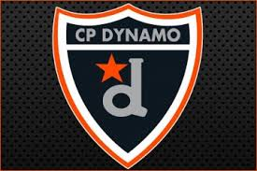

14 U DYNAMO GIRLS HOCKEY TEAM PRESENTS:
“RAVENSWOOD”
DINNER FOR DYNAMO’S
TUESDAY OCTOBER 2OTH 2020

Please help us raise funding for our Dynamo 14 U Girls Hockey Team.

Please present this flyer with the purchase of your food order & portions of the proceeds raised will be donated to our team.

EVERY WEEK WE WILL BE DONATING PORTIONS OF THE FUNDRAISING THAT WE RAISE TO A LOCAL CHARITY SELECTED BY OUR TEAM SPIRIT AWARD RECIPITENT OF THE WEEK
RAVENSWOOD PUB & RESTAURANT
1021 Route 146, Clifton Park, NY 12065
Phone: (518) 371-8771
https://www.ravenswoodpub.com

WE THANK YOU FOR YOUR SUPPORT! PLEASE ADDRESS ALL QUESTIONS TO:
TODDY1970@YAHOO.COM

