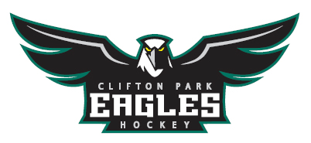
Clifton Park Youth Hockey Association
Tournament Registration Form 2024 - Check payment
Organization Name: ______________________________________________
Team Name:________________________________________Level: (B,C, Other): ________
Division (Circle): 10U 12UB 12UC 14U
Is Your Team USA Hockey Sanctioned (Circle One) YES NO
Website Address:___________________________________________
Contact Person: ___________________________Title:_____________________________
Address:_____________________________________________________________
Phone #:_________________________ E-mail:______________________________
Coach: ___________________________E-mail:______________________________
TEAM COLORS (HOME) _______________(AWAY) _______________
Coach/Manager Signature: _____________________________________________
***By signing above you are stating acceptance to our guidelines and requests listed below
1/5/24 - 1/7/24 : Between the Pipes B, C Tournament (10UB, 12UB, 12UC, 14UB)
Tournament Entrance Fee: 10U: $1000 12U, 14U: $1,200

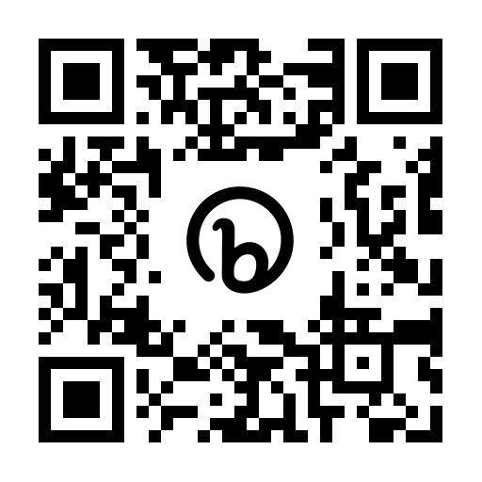
A $200 deposit is required to hold your team’s spot. Deposits and payments can be made via check, through our portal using the QR code below or through the Registration link at: https://bit.ly/3aGfA1Q
If paying by check - please send your completed application and check made out to CPYHA to:

Tournament Director: Kelly Allard
21 Berkshire Dr West
Clifton Park, NY 12065

Clifton Park Youth Hockey Tournaments Contact Email: tournamentsatcpyha@gmail.com

Clifton Park Youth Hockey Association
Between the Pipes 2024
GUIDELINES and REQUESTS
Consideration will be given to your application upon receipt. If we are unable to accommodate your team for any reason, you will be notified and your check will be returned. Additional tournament information, including hotels, vendors, schedule and events can be found on our website at https://bit.ly/3aGfA1Q or our Facebook page: Facebook.com/BetweenthePipesCP
- You will receive notification by email when your team is accepted. Your check will not be cashed until accepted into the tournament. Please email Kelly Allard at tournamentsatcpyha@gmail.com for any questions.

- Tournament games will be played on one of the two ice sheets at the Clifton Park Capital Arena.
- 3 game guarantee.

- Team and player awards will be given to the champion and runner-up teams.

- The tournament is USA Hockey sanctioned, and there will be no admission fees for game spectators.

- Teams should bring both their Home and Away jerseys to each game. Teams must be prepared to take the ice 15 minutes prior to game time.

- USA Hockey's “ZERO TOLERANCE POLICY'' will be strictly enforced. Coaches, players, parents and fans will be required to adhere to this policy at all times. A copy of the policy is online at usahockey.com.
- CPYHA has negotiated rates with our hotel sponsors for your convenience. All teams participating in any CPYHA Tournaments are required to stay at one of the hotels listed on the tournament page. Please only make hotel arrangements after you have been notified of your acceptance to the tournament. Teams not staying with one of our hotel sponsors will be charged an additional $200 fee.

- Teams withdrawing from the tournament after application has been approved will result in the loss of their entry fee.

- We strive to have a good competitive balance within each division and create exciting games and fun memories for all involved.

- Tournament will follow all Covid-19 protocols as outlined by the Department of Health in each region, county, town, city, municipality etc. as well as the arenas/rinks games are played.

